Introducing QRONUS

a Quantum-based scattering C++ code

By,

A. M. Mekawy

1. introduction:

in this report I am introducing both the methods and the results of the first real building block in our code.

2. Giving up on Lippmann-Schwinger (LS) integral Eqn:

at first the LS eqn was introduced as a method to evaluate the differential cross-section values via the Born Approximation, but after realizing, after testing, how inaccurate the first Born Approximation is and the need for the second Born Approximation which give rise to building a computationally expensive code, which contradicts with my target. since the integral would be solved twice at each scattering angle, it was completely discarded. So, the phase shift analysis method was introduced as a replacement.

3. Solving Schrodinger Eqn (the differential form):

one of the requirements for applying the phase shift method is to find the wave function of the system and this step can be done numerically by either Numerov Method or the shooting method, among other methods due to the fact the Schrodinger equation is a boundary value problem (BVP), and under the case of scattering it produces a Hanckel fn, which actually are not really helpful even as a BVP since it reaches zero at infinity and it may have a negative infinity value at the zero point (as in the case of Neumann fns) but what if the code itself can produce its own initial conditions (turning a BVP to an IVP)?

After applying the Frobenius method on a general form central-potential Schrodinger equation, a recursion formula was found, it could be used directly of course, but unfortunately its radius of convergence is really small (from 0.2 to 0.2) so it is perfect as an initial condition generator (ICGEN) hence the step is much more smaller than that, then methods such as the RK family (RK4 and the RKF for example) can be used to find the entire solution to the needed r-value.

The significance of this are:

1. it can be solved till the point where the behavior of lth Bessel function reaches the asymptotic behavior away from the force at point (a) where the effect of the force is negligible.

2. it makes use of fast accurate methods such as the RK4 without the need for guessing or trial and error (as done in the shooting method), specially since it is intended to be solved several times for different l-values.

The need for k*R(kr) instead of psi:

after the evaluation of the wave function for the system it is needed to evaluate the radial component only which is only r*k*psi, the need for this is that it is easier to calculate the phase-shift between such a functions and the asymptotic l-th order Bessel. Then by applying normalization we can identify one of the zeroes at the point (a) and its nearest bessel-twin point then finding the difference between them making the result (Δr) evaluated multiplying it “k”, the wave number, we can evaluate the phase-shift (δ) between the free particle wave (which is just non-shifted bessel) and the scattered wave fn (the obtained solution from the Schrodinger differential form).
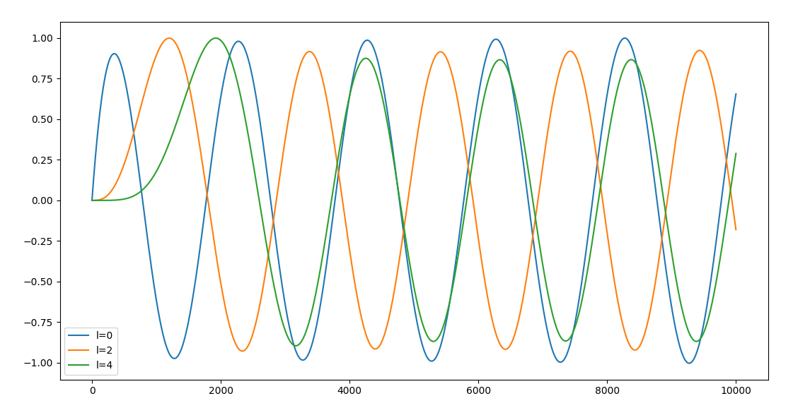

fig(1): normalized rkR(kr) for l=0, 2, 4

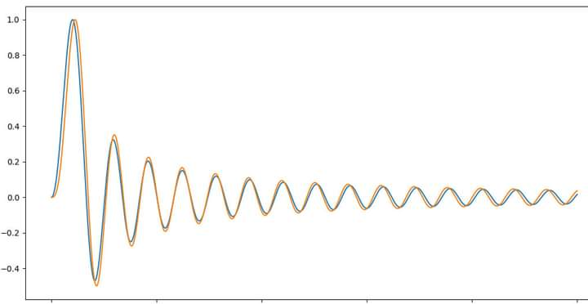

fig(2): shifted wave function (orange) and unshifted wave function (blue)

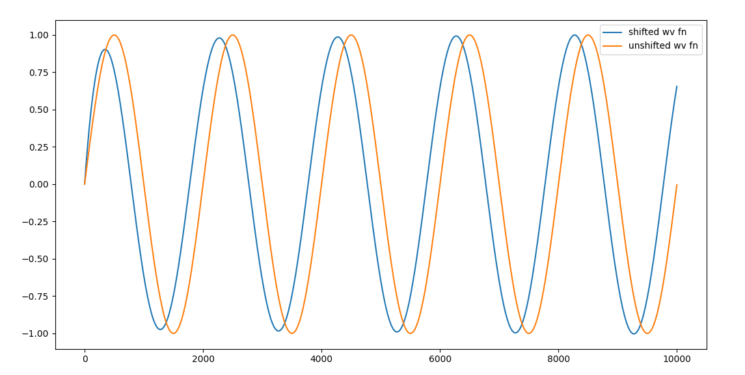
fig(3): shifted rkR(rk) and unshifted rkR(rk)

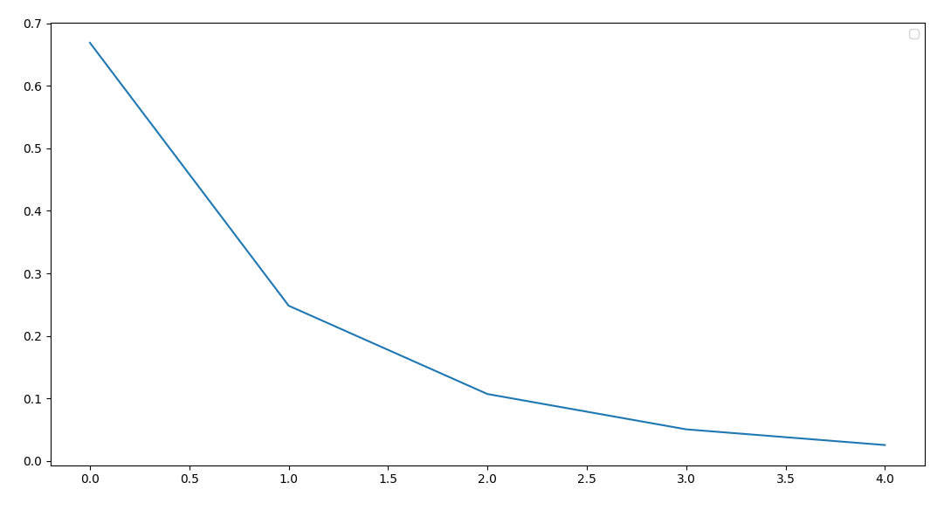

fig(4): the decay of phase-shift (δ) Vs the l-number

4. where to stop?

There are two conditions to stop the solution the first is to make V(r) as small as possible and the second is to reach the point at which the solution starts to follow the Bessel asymptotic behavior.
By applying this, so we can code an auto-determined final r-value.

5. System of units: Atomic units (A. U.) were employed since it is the most suitable units system for computations.

6. Reducing the charged particle-Atom interaction to a two-body problem instead of the usual many-body problem:

such a trick can be done by introducing the suitable potential, which must be:

1. continuous at every point except at zero (infinite at zero)
2. spherically symmetric (to suit our problem and our proposed solution)
3. decays much faster than (1/x) since according to the classical Gauss’ law, the ΣQ=0 inside a Gaussian sphere with radius r>atomic radius, hence the particle will not feel any E-field outside it. But it will have a potential if it is very close to the atom (r is slightly larger than the atomic radius) if the atom was introduced as an electric dipole.
4. must take into consideration the atomic radius.

based on these assumptions the following form was postulated:

V(r)=-Z₁ Z₂ e^{-r/(A*ro)} /r

where

both Z1, Z2 are the charge of the projectile and the atomic number of the target
A: is a constant that mush be less than one.
ro: is the atomic radius.

. The quantity Aro as a whole can be taken in analogy to the Yakawa’s effective range.
. negative value for the repulsion between the negatively charged particle (electron/muon) and the atomic electrons.

Results:

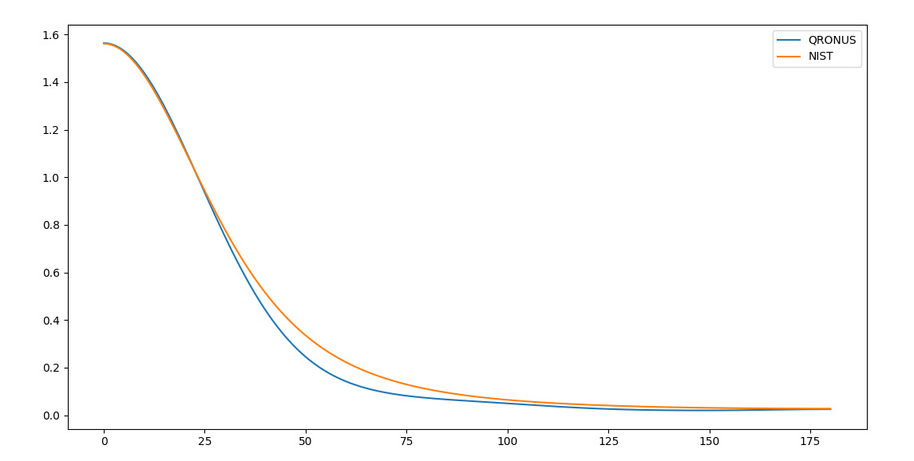

fig(5): the results of the elastic scattering differential cross-section evaluated by QRONUS Vs the NIST online data base for a 50 eV electron hitting an Hydrogen atom
(time:25s, Max. abs. Error = 0.09, Min. abs. Error = 0.001)
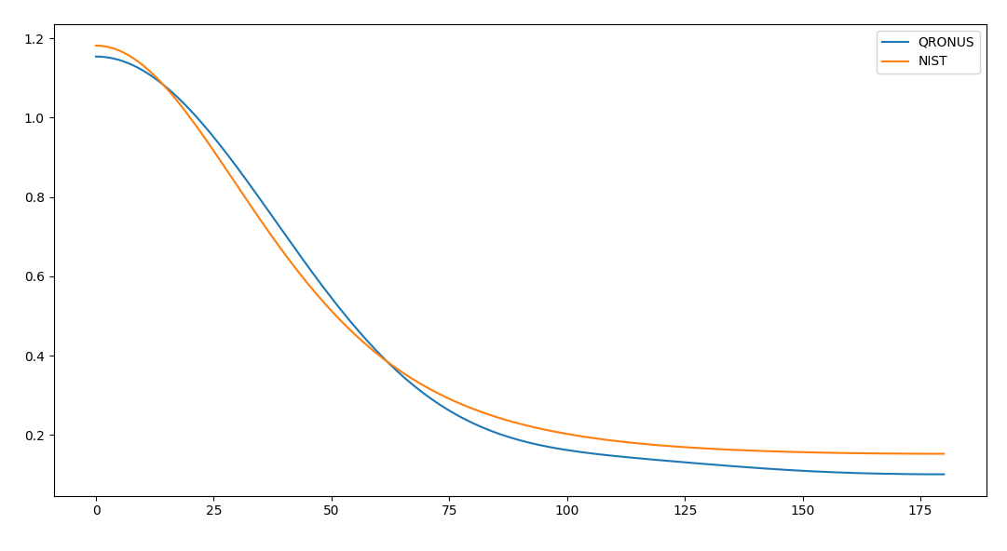

fig(6): the results of the elastic scattering differential cross-section evaluated by QRONUS Vs the NIST online data base for a 50 eV electron hitting a Helium atom
(time:16s, Max. abs. Error = 0.0517, Min. abs. Error = 0.0006)

